Abdullrahman Alghanim

04/18/2025

Cyber FL nodes showing no options other than Allocate Lab

SCT folder contents showing the toolkit files successfully extracted or  
installed

My password Analyzer did not work so I could not complete this step accordingly

Regedit screen showing the value of the Start key in this registry hive

Command prompt screen showing the value of the Start key in this registry hive

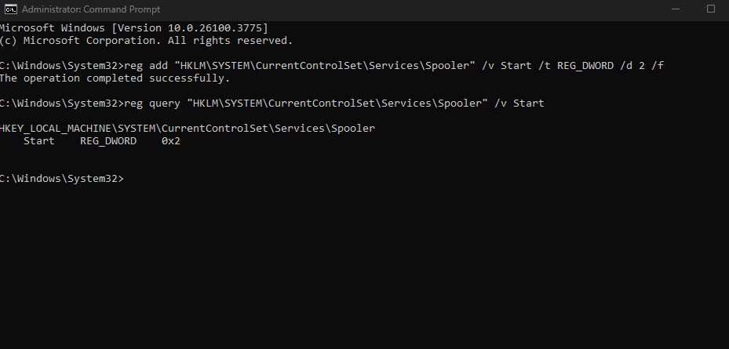

PowerShell output showing SMB1 is FALSE and SMB2 is TRUE

PowerShell ISE showing DSC script execution

